INS3121
SOIL MECHANICS
MIDTERM I
November 16, 2016

Name and Surname:
Q.1/16p | Q.2/18p | Q.3/18p | Q.4/26p | Q.5/22p | TOTAL
Number:
Group:

- a) Explain Atterberg Limits and the experiments that are used to determine Atterberg Limits. What is the importance of Atterberg Limits in engineering purpose? Explain briefly (4p).
b) Explain the terms uniform soil and well-graded soil (4p).
c) What is capillarity? What is its importance in Civil Engineering? (4p).

- Explain briefly the concept of effective stress (4p).

Name and Surname: Number: Group:
- The natural unit weight (γ_{n}), water content and specific gravity (G_{s}) of a soil were determined to be 19.5 kN/m³, 22 %, and 2.67, respectively. Based on this information, compute dry unit weight (γ_{d}), saturated unit weight (γ_{sat}), buoyant (submerged) unit weight (γ’), void ratio (e), porosity (n), and degree of saturation (S) of the soil? (18p).

Name and Surname: Number: Group:
- Classify the soils, according to Unified Soil Classification System (USCS) and American Association of State Highway and Transportation Officials (AASHTO) Classification System (18p).

Soil A w_{L}= %55, w_{P}= %20
Sieve Number: | 4 | 10 | 40 | 200
Percent Finer (%) | 100 | 78 | 64 | 57

Soil B w_{L}= %35, w_{P}= %27, C_{u}=5.1, C_{c}= 2.7
Sieve Number: | 4 | 10 | 40 | 200
Percent Finer (%) | 46 | 38 | 42 | 14

Soil C C_{u}=10, C_{c}= 0.3
Sieve Number: | 4 | 10 | 40 | 200
Percent Finer (%) | 78 | 66 | 54 | 3

Name and Surname: Number: Group:
- A flow net under a concrete dam resting on a permeable soil is given in the figure. A constant head permeability test was performed on a soil sample with a height of 30 cm and a cross-sectional area of 30 cm². A constant head of Δh=55 cm is kept during the test and a volume of 200 cm³ of water was collected over a time of 900 seconds. Based on this information:
- Determine the permeability coefficient (k) of the silty sand soil (6p).
- Calculate the seepage loss under concrete dam per unit width (6p).
- Calculate the water pressures at points A, B, and C (7p).
- Determine whether there is a quick sand condition at the point D or not (7p).

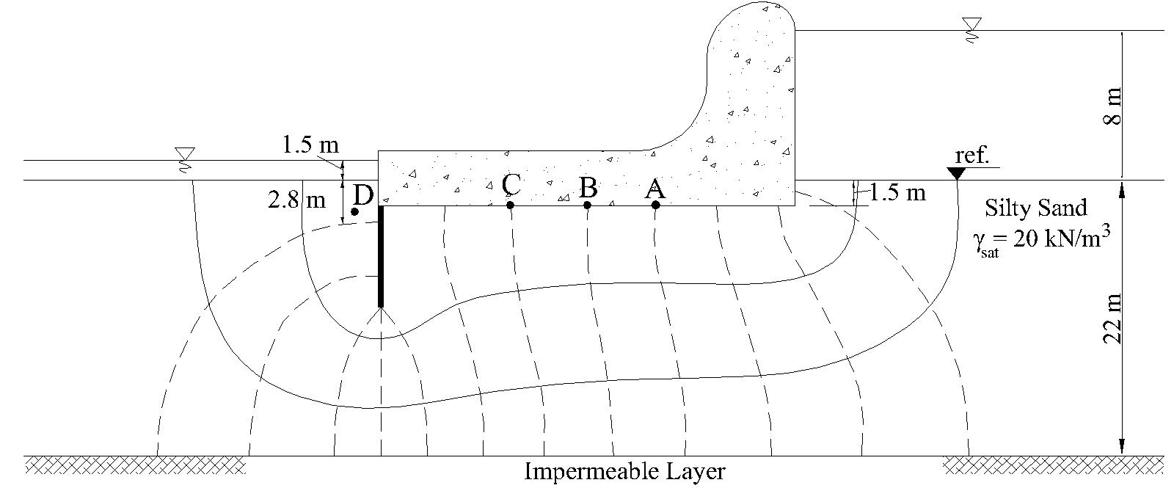

Name and Surname: Number: Group:
- Given the soil profile below:
- Compute the total vertical pressure (σ), pore-water pressure (u), and effective vertical pressure (σꞌ) at points A and B (12p).
- Calculate the vertical stress increase (Δσ) at the center of a 15 m x 25 m uniformly loaded foundation with a pressure of 120 kPa at point B by using 2:1 Method and Boussinesq chart (10p).
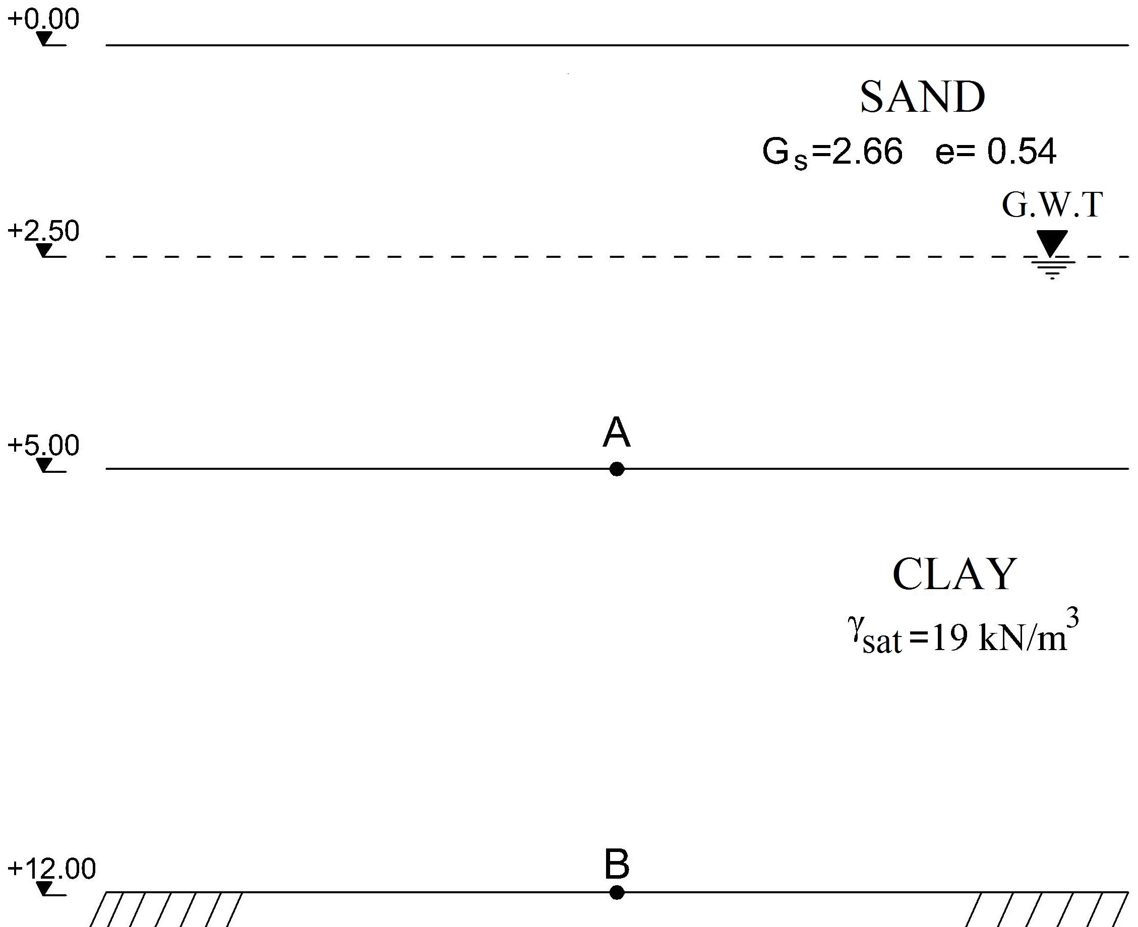

Time is 90 minutes. Good Luck…

